Study of Ethernet Standards.

On a regular Ethernet segment, all stations share the available bandwidth of 10 Mb/s. With the increase in traffic, the number of packet collisions goes up, lowering the overall throughput. In such a scenario, there are two basic approaches to increase the bandwidth.

One is to replace the Ethernet with a higher speed version of Ethernet. Use of Fast Ethernet operating at 100 Mb/s and Gigabit Ethernet operating at 1000 Mb/s belong to this category. This approach requires replacement of the old network interface cards (NICs) in each station by new ones.

The other approach is to use Ethernet switches (let us call it switched Ethernet approach) that use a high-speed internal bus to switch packets between multiple (8 to 32) cable segments and offer dedicated 10 Mb/s bandwidth on each segment/ports. In this approach, there is no need to replace the NICs; replacement of the hub by a switch serves the purpose. This approach is discussed in the following section.

**Ethernet evolution through four generations**

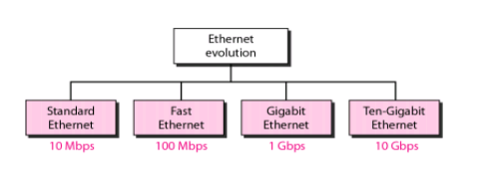

**1) Standard Ethernet:**

* **10Base-5**: It supports 10 Mbps baseband transmission. The standard specifies 0.5 inch coaxial cable, known as *yellow cabl****e*** or *thick Ethernet*. Each cable segment can be maximum 500 meters long (which is indicated by **5** in the convention). Up to a maximum of 5 cable segments can be connected using repeaters, with maximum length 2500 meters. At most 1024 stations is allowed on a single LAN.
* **10Base-2:** It supports 10 Mbps baseband transmission. The standard specifies 0.25 inch coaxial cable, known as *cheapernet or thin ethernet*. Each cable segment can bemaximum 185 meters long. Up to a maximum of 5 cable segments can be connected using repeaters, with maximum length of 925 meters. It may be noted that in this case there is no need for AUI drop cable, which is required in case of 10Base-5 standard.
* **10Base-T:** This standard supports 10 Mbps baseband transmission and uses 24AWG unshielded twisted pair (UTP) cable for both Cat-3 and Cat-5 category cables. A HUB functions as a multi-port repeater with stations connected to it with RJ45 connector. Maximum length of a cable segment is 100 meters. This allows easy to maintenance and diagnosis of faults. As a consequence, this is the most preferred approach used for setting up of a LAN.
* **10Base-F:** It allows long distance connection using optical fiber. The topology is same as 10base-T, but the medium is a pair of optical fiber instead of twisted pair of wire. It has the following divisions:
* 10BaseFP A passive-star topology, up to 1 Km link,
* 10BaseFL An asynchronous point-to-point link, up to 2 Km ,
* 10BaseFB A synchronous point-to-point link, up to 2 km with 15 cascaded repeaters

**2) Fast Ethernet**

The 802.u or the fast Ethernet, as it is commonly known, was approved by the IEEE 802 Committee in June 1995. It may not be considered as a new standard but an addendum to the existing 802.3 standard. The fast Ethernet uses the same frame format, same CSMA/CD protocol and same interface as the 802.3, but uses a data transfer rate of 100 Mb/s instead of 10 Mb/s. However, fast Ethernet is based entirely on 10-Base-T, because of its disadvantage (Although technically 10-BASE-5 or 10-BASE-2 can be used with shorter segment length).

IEEE has designed two categories of Fast Ethernet: 100Base-X and 100Base-T4. 100Base-X uses two-wire interface between a hub and a station while 100Base-T4 uses four-wire interface. 100-Base-X itself is divided into two: 100Base-TX and 100base-FX

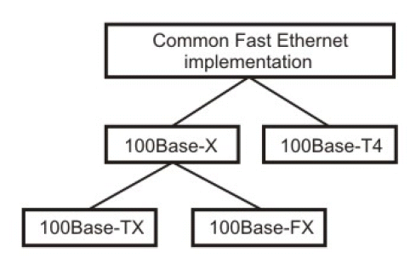

Figure Fast Ethernet implementation

* **100 BASE-T4:**

This option is designed to avoid overwriting. It is used for half-duplex communication using four wire-pairs of the existing category 3 UTP cables, which are already available for telephone services in homes/offices. Two of four pairs are bi- directional; other two are unidirectional. This means that there are 3 pairs to be used for carrying data, in each direction (2 bi-directional and 1 uni-directional) Because 100Mbps data cannot be handled by voice-grade UTP, this specification splits the 100 Mbps flow into three 33.66 Mbps flows.

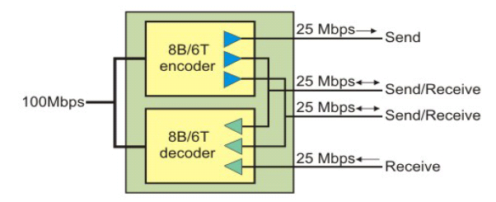

Figure 100BASE-T4 implementation

* **100 BASE TX:**

This option uses two pairs of category 5 UTP or two shielded twisted-pair (STP) cable to connect a station to hub as shown in Fig One pair is used to carry frames from the hub to the station and other to carry frames from station to hub. It uses 4B/5B encoding to handle 100 Mbps using NRZ-I signaling. The distance between station and hub should be less than 100 meters.

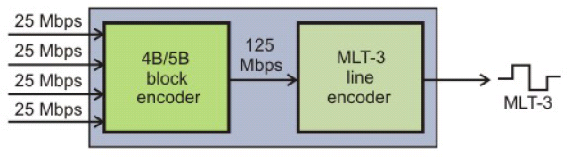

Figure100Base-TX implementation

* **100 BASE FX:**

This option uses two Fiber optic cables, one carry frames from station to hub and other from hub to station. The encoding is using 4B/5B and it uses NRZ-I signaling. The distance between station and hub should be less than 2000 meters.

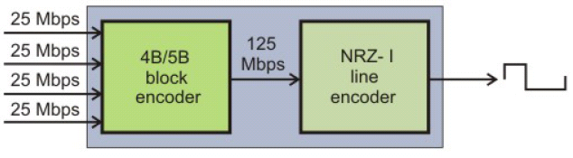

Figure100Base-FX implementation

**3) Gigabit Ethernet**

The primary goal of Gigabit Ethernet is to build on that topology and knowledge base to build a higher-speed protocol without forcing customers to throw away existing networking equipment. As its name implies, Gigabit Ethernet - officially known as 802.3z - is the 1 Gb/s extension of the 802.3 standard already defined for 10 and 100 Mb/s service. Gigabit Ethernet builds on top of the Ethernet protocol, but increases speed tenfold over Fast Ethernet to 1000 Mbps, or 1 gigabit per second (Gbps).

It retains the Carrier Sense Multiple Access/ Collision Detection (CSMA/CD) as the access method. It supports full duplex as well as half duplex modes of operation. Initially, single-mode and multi mode fiber and short-haul coaxial cable were supported. Standards for twisted pair cables were subsequently added. The standard uses physical signaling technology used in Fiber Channel to support Gigabit rates over optical fibers.

i) The cabling requirement of gigabit Ethernet is very different. The technology is based on fiber optic cable. Multi-mode fiber is able to transmit at gigabit rate to at least 580 meters and with single-mode runs exceeding 3 km. Fiber optic cabling is costly. In order to reduce the cost of cabling, the 802.3z working group also proposed the use of twisted-pair or cable or coaxial cable for distances up to 30 meters.

(ii) Gigabit Ethernet also relies on a modified MAC layer. At gigabit speed, two stations 200 meters apart will not detect a collision, when both simultaneously send 64-byte frames. This inability to detect collision leads to network instability. A mechanism known as carrier extension has been proposed for frames shorter than 512 bytes. The number of repeater hops is also restricted to only one in place of two for 100 Base-T.

(iii) Flow Control is a major concern in gigabit Ethernet because of buffer overflow and junked frames in heavily loaded condition. The solution proposed by IEEE subcommittee is the 802.3x. The X-on/X-off protocol works over any full-duplex Ethernet, fast Ethernet or gigabit Ethernet link. When a switch buffer is close to capacity, the receiving device signals the sending station and tells it to stop transmitting until the buffer becomes empty.

(iv) Finally, one important feature, which Ethernet technology lacks, is the Quality of Service (QoS). The gigabit Ethernet is a connectionless technology that transmits variable length frames. As such, it simply cannot guarantee that the real-time packets get the preferential treatment they require. The IEEE subcommittee developed two specifications that will help Ethernet provide the required QoS. 802.lq tags traffic for VLANs and for prioritization. 802.lp is a signaling scheme that lets end station request priority and allows switches to pass these requests along the path.

**4) Ten-** **Gigabit Ethernet**

The 10 Gigabit Ethernet standards extend the IEEE 802.3ae* standard protocols to a wire speed of 10 Gbps and expand the Ethernet application space to include WAN-compatible links. The 10 Gigabit Ethernet standards provides a significant increase in bandwidth while maintaining maximum compatibility with the installed base of 802.3 standard interfaces, protects previous investment in research and development, and retains the existing principles of network operation and management.

Under the Open Systems Interconnection (OSI) model, Ethernet is fundamentally a Layer 1 and 2 protocols. 10 Gigabit Ethernet retains key Ethernet architecture, including the Media Access Control (MAC) protocol, the Ethernet frame format, and the minimum and maximum frame size. Just as Gigabit Ethernet, both 1000BASE-X and 1000BASE-T, followed the standard Ethernet model, 10 Gigabit Ethernet continues the evolution of Ethernet in speed and distance, while retaining the same Ethernet architecture used in other Ethernet specifications, except for one key ingredient. Since 10 Gigabit Ethernet is a full-duplex only technology, it does not need the carrier-sensing multiple-access with collision detection (CSMA/CD) protocol used in other Ethernet technologies. In every other respect, 10 Gigabit Ethernet matches the original Ethernet model.